You're not dead -- you're life-impaired
Friday, October 07, 2005
By Peter Leo, Pittsburgh Post-Gazette
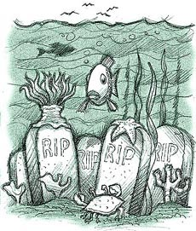
James Hilston, Post-Gazette
Click illustration for larger version.
You'll sleep with the fishes
Looking for something interesting to do with your body after death, something that will enrich the planet before global warming really heats up and we all get cremated? Consider Eternal Reefs. For a modest fee, you or the deceased in your life can help restore some of the estimated 30,000 square miles of dead reefs around the world. This is no joke. Eternal Reefs' founder, Don Brawley of Decatur, Ga., is a reef-builder by trade. Six years ago, his father-in-law asked him to do a favor: When I die, he said, put my remains mixed into a reef ball, sunk into the water. Father-in-law figured it was better to be in the sea, surrounded by coral and fish, color and action, than to be planted in a field with a bunch of stiffs going nowhere. A few months later, when the man died, Mr. Brawley kept the promise. And a new company was born. He stresses that being part of an artificial reef is more environmentally useful than simply sprinkling ashes in the sea. The artificial reef is made from pollutant-free concrete mixed with the cremated remains and costs from $1,500 to $5,000. Eternal Reefs has permission to place artificial reefs in the Atlantic, off South Carolina and Florida, and in the Gulf of Mexico.
-- www.eternalreefs.com.

