Topsail Island Info

Your Bridge to Topsail Island

Dare’s Reef – Sanctuary Of Life
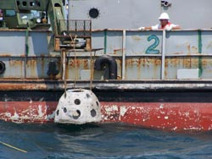
Dare’s Reef is placed in the ocean by the ship "Bay West" staff.
Family members and volunteers from the Karen Beasley Sea Turtle Rescue and Rehabilitation Center gathered this week to pay tribute to their loved ones, a family pet and to a sea turtle named "Dare" as artificial reefs made from their remains were placed on the ocean’s floor in their memory. Although it was a solemn occasion, it was one celebrated with joy.
The story of Dare is bittersweet. Found in 1999 in Dare County, a young injured Kemp’s Ridley sea turtle was brought to the Karen Beasley Sea Turtle Rescue and Rehabilitation Center in Topsail Beach, North Carolina. She was found diseased, underweight and with boat strike injuries and ulcers. The staff and volunteers worked very hard to help with her recovery. In time, she was well enough to be released, however, she never tasted freedom again.
A hurricane named Floyd had other ideas.
Because of the storm, Dare spent four days in her tank twenty-seven feet up in the top of a tree, floating in contaminated floodwaters. Doctors found that she had physical and neurological injuries and possibly had been hit by lightening as well. Despite special medical treatments and the heroic efforts of the sea turtle hospital volunteers, Dare died on March 10, 2005.
What the volunteers didn’t realize at the time was that her death was a new beginning, not only for Dare, but for eight others as well.
When Eternal Reefs heard of Dare’s plight, they offered their assistance. Together, with the staff of the sea turtle hospital, they shared efforts to make "Dare’s Reef," the only Sea Turtle Memorial Reef in the United States.
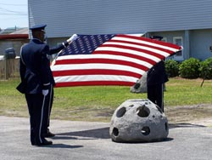
Eternal Reefs also provides a military honors ceremony which was held prior to the placement of the reefs for service member Authur Edwin Dumont who died earlier this year.
Dare’s cremated remains were combined with an environmentally safe concrete and molded into a "reef ball" which will house aquatic creatures living near the ocean floor. Permits were processed that allowed the artificial reefs to be buried offshore near the turtle hospital. The area is now known as "Dare’s Reef" and houses some 42 reef balls made of both human and animal remains.
George Frankel, an Eternal Reef spokesman, said, "Every person has their own reason for doing this…their own justification. A lot of it boils down to involvement and participation. There is also a sense of closure in this. It’s not just a memorial… it’s a tribute."
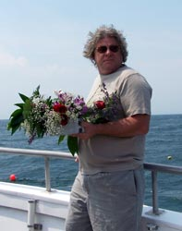
The husband of Ursula Julian prepares to toss a small memorial over the reef. He has plans of returning in August to dive down to Dare’s Reef.
Eternal Reefs, located in Sarasota, Florida, begins with a process of mixing cremated remains with a special concrete that will not harm the environment. A family or loved one can come to the facility and mix it personally. Writing, handprints or images can be applied to the reef ball, or any number of items symbolizing the life it represents. The only real rule is that Eternal Reefs must place the finished product in a pre-approved location. To date, many already exist and several are scheduled.
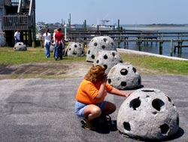
Sherry Monnier visits Kevin’s reef during a memorial service.
Sherry Monnier’s husband, Kevin, who died six years ago, said, "Kevin was a scuba diver. I couldn’t dive but I would snorkel above him while he did. He would have loved this idea."
Sherry still lives in Indiana and, together with her best friend, traveled to the memorial site to witness Kevin’s last dive.
She had met Kevin at a public swimming pool when she was only 16 years old and married him a month before her 18th birthday. They were married for 21 years.
After three years of fighting a rare autoimmune disease and exhausting all known medical protocols, Kevin opted for an experimental treatment plan his doctors placed before him.
"He told me, ‘If I try and it works on me, great. If I do it and it doesn’t work on me, maybe they will learn enough from me to help somebody else.’" said Sherry. "He was a very respectful person and this (the ocean) was second nature to him. He always conducted himself with dignity, grace, humor and partnership. I admired him. I didn’t want to just put him anywhere."
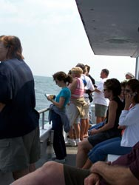
Family members and friends watch the placement of the reefs onboard the Captain Hook charter boat.
The family of William Stover had another idea. Why not make two reefs, one for William, who died in the year 2000, and one for the family’s Westie, Scruffy, who had died a few years later?
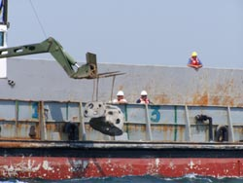
William Stover and dog, Scruffy, were buried together in Dare’s Reef.
One of Stover’s twin daughters, J. Holder from Duluth, Georgia, said, "My dad was really into the ocean. He volunteered for the Dolphin Project. He would take pictures of their fins and catalog them. This was perfect. When we went and cast the reef in Sarasota, Florida, we knew we were doing the right thing. We knew he would love this."
"Dad was Scruffy’s favorite person," she added with a laugh.
Nearly fifty people, family and friends, braved the rough seas on board Captain Hook’s Charter, to take part in this personalized memorial. The air was a mixture of sadness, joy and a hope for the future that their loved one’s last contribution would benefit the earth’s creatures.
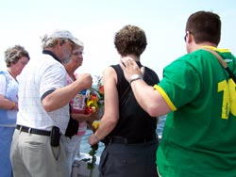
Members of Julie Lynn Riley’s family toss flowers and a miniature reef in her honor over the reef site.
Julie Lynn Riley’s family came all the way from Wichita, Kansas, to place her reef along the shores of North Carolina.
"It was my daughter’s choice," said Julie’s mother, LeeAnn Erickson. "When she was home sick from chemo and radiation, she watched the Discovery Channel. A little clip on the turtle reef came on."
Last Thanksgiving, Julie sat down with her family and told them about Eternal Reefs. She shared her information from Eternal Reefs that she had received with them.
"It was her way of asking for permission, " said LeeAnn. "I told her, ‘whatever you want, dear. That’s what you’ll get.’"
Julie was only thirty-six when she succumbed to cancer this year.
"My daughter chose this particular spot because of her love of animals. She thought this just had to be the spot for her."
Julie and her brother had been scheduled to be donors. Because of the cancer, however, she knew that she would not be able to do that.
"This was the only way that she felt that she could give back to the earth."
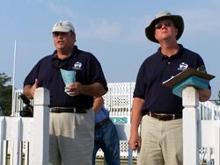
George Frankel (left) and Chuck Kizina speak to memorial participants about the program.
George Frankel and Chuck Kizina, both representatives for Eternal Reefs, were on board with the assembly and made sure everyone was comfortable with the process. They also supervised the memorial.
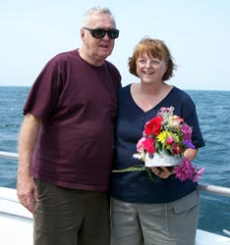
Family members ready for the memorial held at high noon.
George had this to say about the staff at Eternal Reefs, "There is not a person on our team that does not love the entire process… love families… love doing it…and we love the environmental contribution that comes out of this. It’s just astonishing."
For families and friends of Dare the sea turtle, Arthur Edwin Dumont, Ursula Julian, Anita Faye Justice, Kevin A. Monnier, Julie Lynn Riley, Rowleen Smith, William R. Stover and Scruffy Stover, the living reef is a symbol of both loss and joy. It’s also one of fulfillment that their loved ones will go on living through contribution.
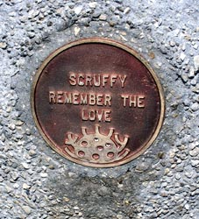
The personalized emblem on Scruffy’s reef says it all, "Remember the love."
For an additional story about this event by sea turtle hospital volunteer and author Karen Sota, please click here.
Click here for additional information about Eternal Reefs.
Also check out the sea turtle hospital here.
Comments/questions, contact: editor@topsailpublishing.com
This entry was posted on Sunday, June 11th, 2006 at 11:45 am and is filed under Holly Ridge, Hampstead, Sneads Ferry, Surf City, Topsail Beach, North Topsail Beach, Camp Lejeune, Topsail Island, Community, Headlines, Turtle Hospital. You can follow any responses to this entry through the RSS 2.0 feed. Responses are currently closed, but you can trackback from your own site.

